Excel Assignment - 15

1. **Create a Pivot table and show what the main export product is?**

***Scale***

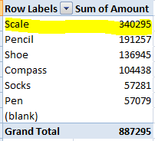

1. **Create a bar graph showing the amount spent for each product?**

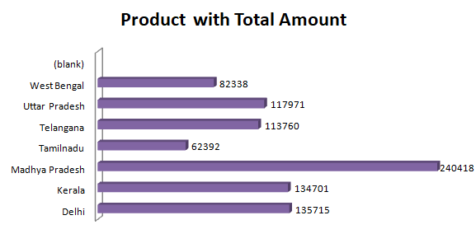

1. **Create a Pivot table to show The sales in each city**

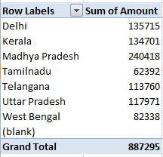

1. **Create a chart showing the amount spent for each product in each city.**

